The Interim Search Committee is pleased to announce that Deck Guess has accepted God’s call to serve our church in a transitional role as we seek a full-time pastor. Deck’s first Sunday in the pulpit will be August 25th.

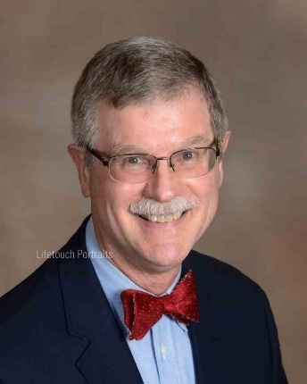
Meet Deck and Deb Guess
Originally from Union, SC, Deck has been coming to the High Country since the 1970’s, when his parents built a vacation home on Beech Mountain. Deb grew up in Bristol, TN. They both love the mountains, mountain people, mountain culture and are delighted that God has called Deck to serve Banner Elk Presbyterian Church as Transitional Pastor.
Deck has had training as both a Natural Church Development coach and a Transitional coach and has worked with 7 or 8 churches in that capacity. He is excited to begin work with a church that already has momentum and wants to keep building on it to expand its mission.
One of Deck’s favorite aspects of ministry is worship leadership. He loves to preach the Word but in recent years has a deepening appreciation for how music and art open people up to God. Music and visuals often communicate on levels deeper than words and they can be avenues for everyone to engage more fully in worship.
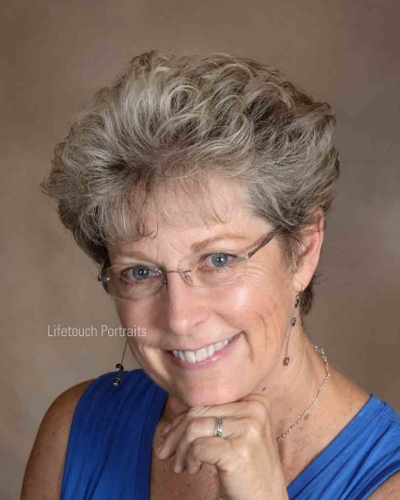
Deck told the Lord he didn’t want to go to Mississippi or Florida. Of course, he was called first to Mississippi for 5 years, then to Florida for 6! Those were wonderful experiences and he has learned just to go with God’s flow.
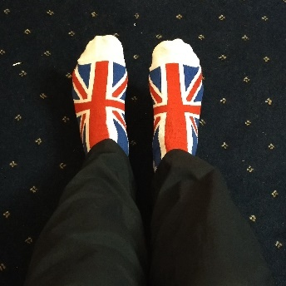
Even though she has “officially” retired from church work (Christian Educator for Providence Presbytery, Director of Campus Ministry for Charleston Atlantic Presbytery), Deb is still active in artistic pursuits with Re: Create and the Art, Recreation, and Worship workshops at Montreat. She is also a jewelry artist and teaches jewelry making.
During his down time, Deck enjoys tennis, skiing, and has been known to work in fused glass. He also has quite a collection of quirky socks, (people sometimes pull up his pant legs to check them out). Socks have spawned quite a few children’s sermons. Deb and Deck have 4 incredible children, all grown, and have FINALLY gotten their first grandchild!

